**Embedded AI: Automated Testing Methods**

**ZCU104 User Manual**

1. **Product Introduction**
   1. What is it?

It is a Field Programmable Gate Array board. System on Module (SoM)

* 1. What does it do?

It enables designers/users to “jumpstart” designs.

* 1. When is it useful?

It is useful for in the building and use of embedded vision applications, such as surveillance.

* 1. Why should you buy it and always use it?

It should be bought when needed to build and/or use an embedded vision application that would be use in everyday life.

1. **Product Tour**
   1. Picture of System – aside from monitor and Linux environment

* 1. Labeled Picture – Multiple labels, but only major components will be named

5 – USB Port

6 – SD Card Interface

9 – Ethernet Port for Internet Connection

10-11 – HDMI Video Outputs

22 – Power On/Off Switch

23 – Connector for AC Power Source

30 – Mode Switches (that should not be moved anymore)

* 1. User Interfaces
     1. Linux Environment
     2. Serial Communication
     3. SSH Communication
     4. Embedded Linux Environment when connected to the board

1. Using the Product
   1. The product should be placed on a flat surface with no objects in the surrounded area. If needed to be around other objects, make sure they will not fall o the board and/or cover the fan above the board.
   2. Once making sure the product is safely placed on a surface, BEFORE flipping the power on switch, connect all the needed connections, make sure the SD card is pressed into the connector properly. Once all this is done, flip the power switch to on.
   3. When turning off the product, no precautions should be taken. On can just flip the power switch is off.
   4. Procedures for Use
      1. Once the system is properly powered on, determine what connection method will be used.

If UART serial communication is chosen, open an application such as Putty or TeraTerm. Find your UART COM port and select it. Baud rate needed will be **115200.**

If SSH is chosen, find the IP address of the board. Then, in a Linux environment, use this command “ssh root@IP_ADDRESS”

* + 1. Once connected to the board, all applications, examples, and information on the board will be available for use.
    2. Example for Resnet50 run:

Navigate through directories to the resnet50 folder using the “cd” command. For example, “cd Vitis-AI/examples/VART/resnet50”

Once there, run the following command to run the example:

“./resnet50 /usr/share/vitis_ai_library/models/resnet50/resnet50.xmodel”

1. Troubleshooting
   1. Symptoms for an error would be that the example, code, or demo is taking a long time to run.
   2. Error messages will display on the terminal.
   3. Depending on the error, such as connection error, package installation error or syntax error; the proper method to solve the error should be taken.

If connection error: check the internet, cables, or other connections made.

If package error, install the proper needed packages.

If syntax error, fix the syntax error in code.

1. Maintenance
   1. No serviceable components on board.
   2. There are no steps needed to clean the device.
   3. This device does not operate with batteries. It is powered by AC source.
   4. The installation and replacement of batteries is not applicable.
   5. The only spare parts are the other pieces of equipment, such as: camera, monitor for display, and USB extender.
2. Health and Safety
   1. No health and safety procedures or guidelines to be applied to this device.
3. Product Specifications
   1. Picture of all the connections for the ZCU104 board

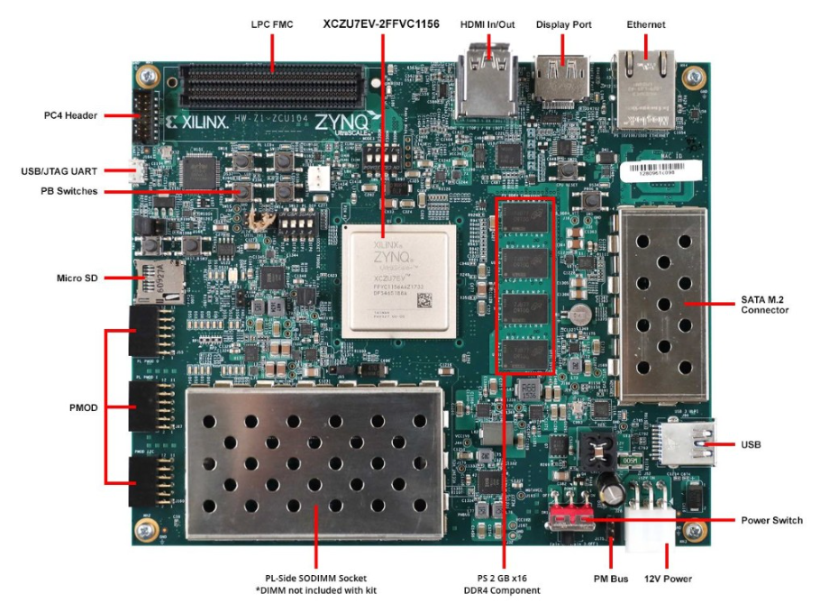

* 1. Product Description

The ZCU104 Evaluation Kit enables designers to jumpstart designs for embedded vision applications such as surveillance, Advanced Driver Assisted Systems (ADAS), machine vision, Augmented Reality (AR), drones and medical imaging. This kit features a Zynq® UltraScale+™ MPSoC EV device with video codec and supports many common peripherals and interfaces for embedded vision use case. The included ZU7EV device is equipped with a quad-core ARM® Cortex™-A53 applications processor, dual-core Cortex-R5 real-time processor, Mali™-400 MP2 graphics processing unit, 4KP60 capable H.264/H.265 video codec, and 16nm FinFET+ programmable logic.

1. References
   1. Source: https://www.xilinx.com/products/boards-and-kits/zcu104.html#information